Concept Assignment 5 Submission
PLTW Engineering Introduction to Engineering Design Core Training

Modeling Skills
Student Name: _____________________________ Date:__________ Period: _________

Part 4.2: Model Creation
Did you see the two videos: _____Name the video#1__________ Name the video #2________

Part 1: Concept Modeling

Insert an image of your model 1 from your computer drawing and iProperties from inventor, like the examples.
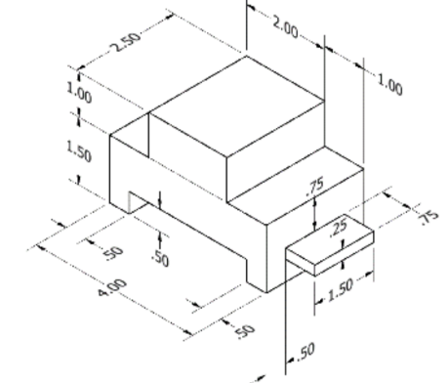

- Create a 3D solid model of the object above using the most efficient method.
- Which method (additive, subtractive, or a combination of additive and subtractive) did you use? Why do you feel it was most efficient?

Part 2: Concept Modeling
Insert an image of your model 2 from your computer drawing and iProperties from inventor, like the examples.
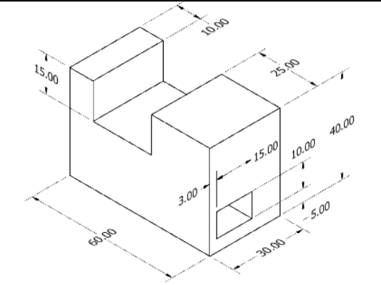

- Create a 3D solid model of the object above using the most efficient method possible.

- Describe the method you used to model the object. Why do you feel it was most efficient?

Part 3: Concept Modeling
Insert an image of your model 3 from your computer drawing and iProperties from inventor, like the examples.
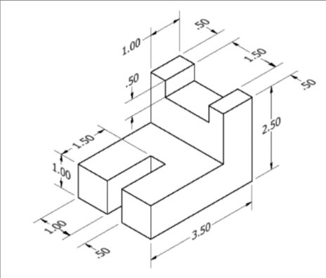

- Create a 3D solid model of the object above using only additive procedures.

- Create a 3D solid model of the object using only subtractive procedures.

- Which method (additive, subtractive, or a combination of additive and subtractive) do you feel would be the most efficient method for creating the object? Why?

Part 4: Concept Modeling
Insert an image of your model 4 from your computer drawing and iProperties General and Physical, from inventor, like the examples.
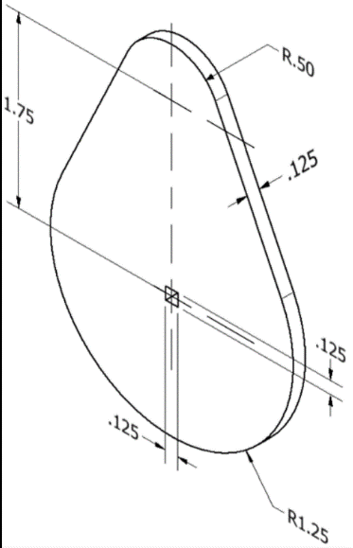
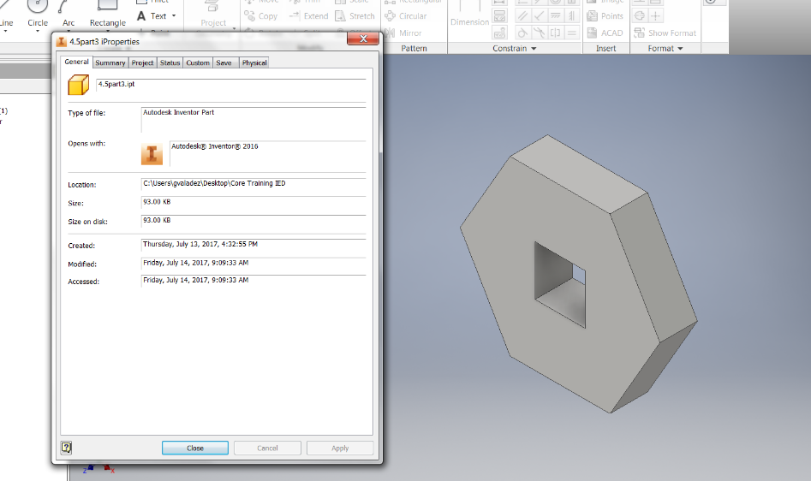
- Describe the method you used to create the object.

- Explain the most efficient procedure using a single extrusion to create this 3D solid model.

Insert an image of your model 4 iProperties Physical,

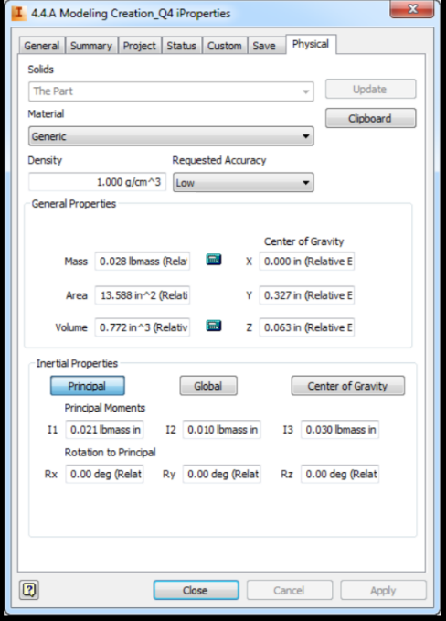

Conclusion questions:
- Why is it important to consider efficiency when planning your method of creation before you begin to model an object in CAD?

- How can the information provided in the browser of the CAD software help you compare the efficiency of two different methods of modeling the same object?

